Lab: Introduction to Locations

In this lab, you will configure various widgets to make navigable links. In the first part of this exercise, you will link the employer name in ABContactDetailsPersonDV to the contact details page for the employer. In the second part of this exercise, you will link the employee name in ABCompanyEmployeesLV to the contact details page for the employee.

Requirements

This lab requires that you use TrainingApp 8.0, Guidewire Studio 8.0, and Chrome as your web browser. To view, edit, and delete various contacts, log in to TrainingApp as Alice Applegate. The default URL for TrainingApp is <http://localhost:8880/ab/ContactManager.do>. The login/password for Alice Applegate is aapplegate/gw.

1. Configure navigable links

Part A

In ABContactDetailsPersonDV, in Employment Info, there is the Employer widget. Currently, there is no navigable link for the Employer widget to the employer contact. A user would need to search for the Albertson's contact. In this part of the exercise, you will link the employer name on ABContactDetailsPersonDV to the employer contact details page.

Tasks

1. Modify the Employer widget to link to the employer's Details page.

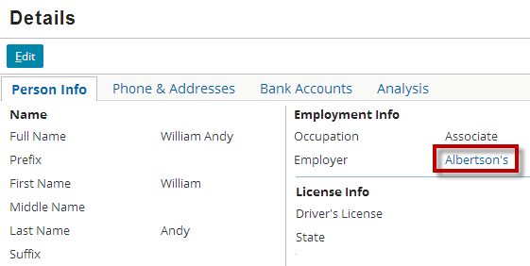

Note: If the person does not have an associated employer, there is not a visible link, but the widget is clickable. If you click on the empty link for a person that has no employer, TrainingApp will throw null pointer exception. In a later lab, you will modify the behavior of the input widget in order to disable the empty link.

Part B

In ABContactDetailsCompanyDV, in Employee info, there is the ABCompanyEmployeesLV. The list view panel shows all the employee contacts associated with the employer. Currently, there is no navigable link for the employee name in the list view panel to the employee contact. A user would need to search for the specific employee contact.

In this part of the exercise, you will link the employee name in the ABCompanyEmployeesLV to the employee contact details page.

Tasks

1. Modify the list view panel so that each employee name links to the contact details page.

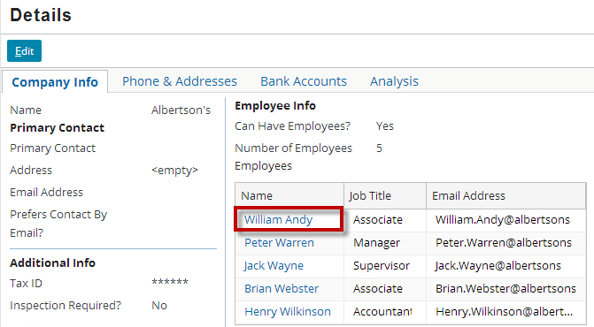

Verification

1. Log in to TrainingApp
2. Log in as Alice Applegate.
3. Reload the PCF changes
4. In TrainingApp, reload the changes to the PCF file(s).
5. Make associations between Person contacts and Company contact
6. Edit the employer field for various person contacts.
7. View the Details page for Person contacts
8. For your modified contacts, visit the details page.
9. Confirm that you are able to click a navigable link to the listed employer contact.
10. View the Details page for Company contact
11. Confirm that you are able to click a navigable link for each employee contact.

|  |  |
| --- | --- |
|  | Stop and ask your instructor to review your completed lab. |